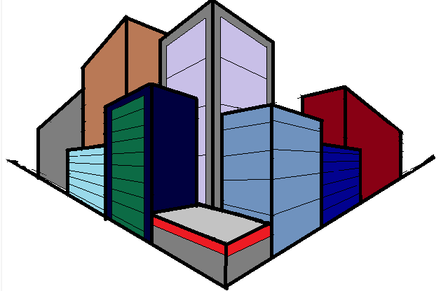
City Project GRASP

Goal: Design a model city layout, design packet, and sales pitch.
Role: City Planner, Development USA
Audience: State Commissions on Charter Cities
Situation: With the boom in population, the United States has decided to start Charter Cities across unused portions on the country. In order to ensure that these cities thrive, meaning that they both attract people to live there and also adequately support them while they are they, the US government is soliciting bids from the top architects in the land to submit their bids.
Performance: Your city design is comprised of four key components: Cityscape View, Mapped Plan, Mathematical Justification, Math Story.
Cityscape View
This is what will hook millions of residents from around the United States and get them interested in living in your charter city. Use your mastery of parallel lines, vanishing points, and artistic talents to wow the judges.
Mapped Plan
You will need to create a map for a portion of your city, which must include the following
a) Two pairs of perpendicular lines (of differing slopes)
b) School
c) Firehouse
d) Police Station
e) Grocery Store
f) Commercial Center
g) Single Family Houses
h) Apartments
i) Hospital
j) Park
You will need to create a legend that indicates which images, or abbreviations, stand for which buildings.
In this legend, you will need to include the calculations you made to indicate the slopes of two sets of lines are perpendicular.

Math Distance Story
You need to write a quick story about living in your town and walking somewhere - to school, the grocery store, wherever. You then need to calculate two paths to get there, and measure both paths using the measurement tools. In your story, you need to show the calculations for both paths, and describe which one you take more often.

City Project Guide
Rough Draft – Sketch out your city here first. Map your streets first, and as you go map off the checklist of items.
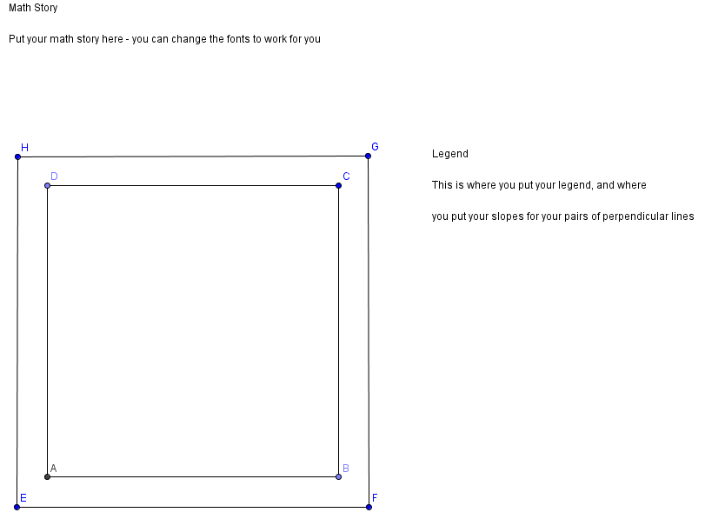

Street One Street Two Perpendicular?___
-Line 1 ___ -Line 3 ____
-Line 2 ___ -Line 4 ____

Street Three Street Four Perpendicular?___
-Line 5 ___ -Line 7 ____
-Line 6 ___ -Line 8 ____

School___ Legend___
Firehouse___ Slope Calculation Show___
Police Station___
Grocery Store___
Commercial Center___ Distance Path 1 _____
Single Family Houses___ Distance Path 2 _____
Apartments___
Hospital___
Park___ CityScape View_____

Rubric
Topic | Score | Comments/Revisions
On Time (Work Hard Grade) | /4
CityScape View | /4
Map: Building Included/Legend | /4
Map: Two Pairs or Parallel Lines | /4
Map: Slopes Calculated, Perpendicular Calculation Shown | /4
Story: Writing | /4
Story: Distance | /4
Total Average for standards G.MG.1, G.MG.3

