Warm Up – Hole in One Practice
Using the law of angle of reflection (ball bounces off at the same angle it hits, make these be a hole in one.
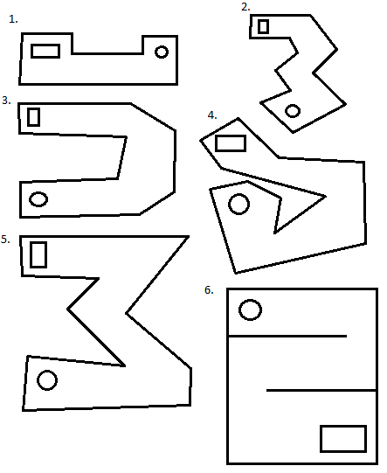

A new mini golf course is opening up, and the contractor has asked for designs that have an area between 90 unit² and 100 unit² . The following design was submitted. You work for the contractor and are tasked with doing the following two things.
- Calculate the area of the mini golf course
- If necessary, change the mini golf course (by marking on the design) so that the area of the course is within the specifications of the course designers.
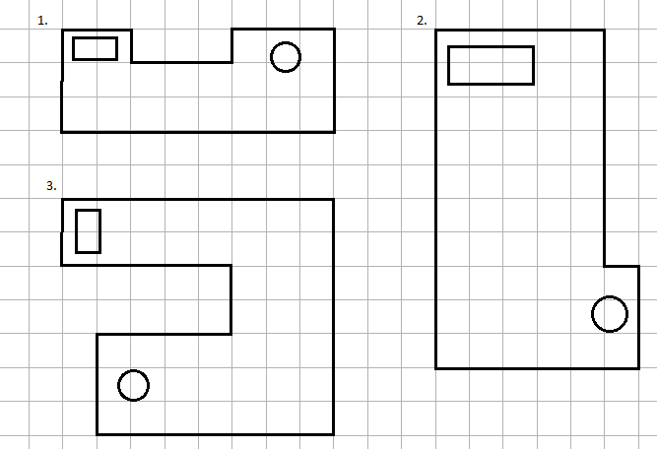
Step 2 Cont
Describe how you changed the course to meet the design specifications.

Step 1
Submitted Desgin Area
Hole 1 = __________
Hole 2 = __________
Hole 3 = __________
Total = ___________
Step 2
Change the course so that the area is between the limits. Calculate the new area.
Hole 1 = __________
Hole 2 = __________
Hole 3 = __________
Total = ___________

