School Concept Development and Poster Rubric
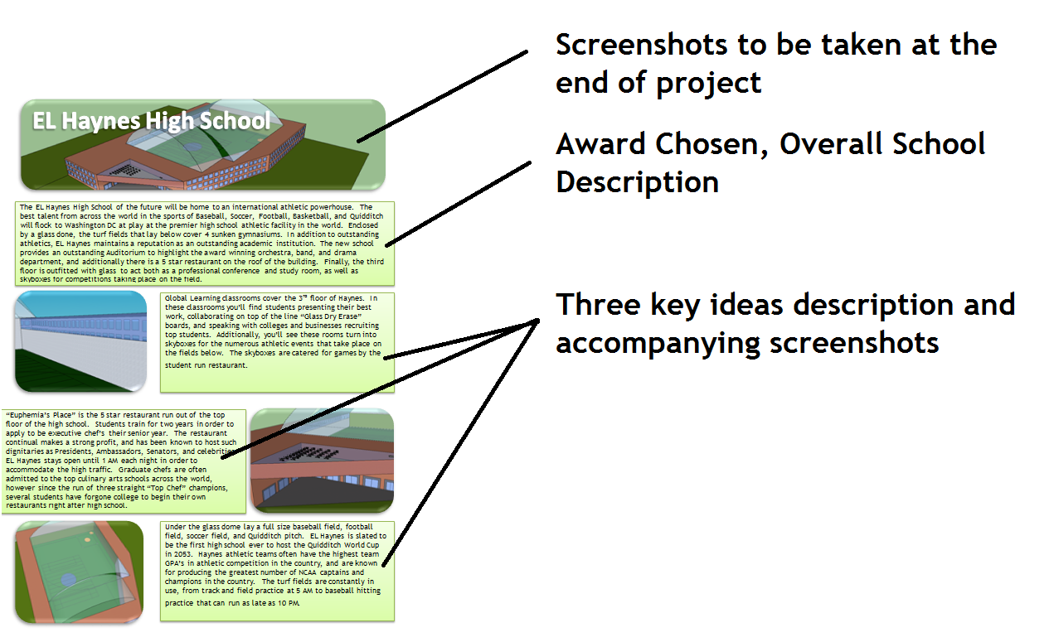

Your projects will be judged by panels that will not only weigh the quality of your video presentation, but the quality of your concepts and implementation in design. You must choose three ideas that will be the foundation of your school and be presented to the judging panel. These descriptions will be displayed prominently on your poster, next to pictures of the ideas in action in your building. See the rubric at the below to see how you will be graded for your poster.

Category | 4 | 3 | 2 | 1
Presentation Quality | Poster is professionally finished, neat, well formatted, and includes four screenshots of the building. Poster is appealing to the eye, with a common theme that enhances the presentation. | Poster is professionally finished, neat, well formatted, and includes four screenshots of the building. | Poster is mostly professionally finished, neat, well formatted, and includes four or less screenshots of the building. | Poster is not professionally finished, neat, or well formatted, and includes less that four screenshots of the building.
Writing/Grammar | Language is impressive and skillfully used. Grammar and conventions are nearly flawless. | Language is clear and focused. Grammar and punctuation are solid. | Language is generally clear. Some grammar and punctuation errors, but these do not impede understanding of the text. | Use of language is unclear or confusing. Grammar and punctuation errors impede understanding of the text.
Theme/Intro Paragraph | Thesis is sophisticated, with a well-developed argument, indicating direction of body paragraphs. | Thesis provides a solid argument and indicates general direction of essay. | Thesis does not indicate essay direction but proposes an argument. | Thesis neither proposes an argument nor indicates organization or direction of essay.
Idea One | Idea is creative, innovative, and clearly tied to the architecture award. The idea is clearly demonstrated in the screenshot of the building. Clear thought, reflection, and purpose is seen in description of idea. | Idea is creative, innovative, and clearly tied to the architecture award. The idea is clearly demonstrated in the screenshot of the building. | Idea is somewhat original, but is missing a clear connection to the award. Idea is not fully flushed out. | Idea is missing and or not tied to the award application. Lacking thought/focus.
Idea Two | Idea is creative, innovative, and clearly tied to the architecture award. The idea is clearly demonstrated in the screenshot of the building. Clear thought, reflection, and purpose is seen in description of idea. | Idea is creative, innovative, and clearly tied to the architecture award. The idea is clearly demonstrated in the screenshot of the building. | Idea is somewhat original, but is missing a clear connection to the award. Idea is not fully flushed out. | Idea is missing and or not tied to the award application. Lacking thought/focus.
Idea Three | Idea is creative, innovative, and clearly tied to the architecture award. The idea is clearly demonstrated in the screenshot of the building. Clear thought, reflection, and purpose is seen in description of idea. | Idea is creative, innovative, and clearly tied to the architecture award. The idea is clearly demonstrated in the screenshot of the building. | Idea is somewhat original, but is missing a clear connection to the award. Idea is not fully flushed out. | Idea is missing and or not tied to the award application. Lacking thought/focus.
Overall Grade
Architectural Award Competing For: _____________________________Name ____________________
Idea One
My idea is
This connects to the ________________________ school of the future because
You can see in the my design how
Be Creative – How else will you capture the imaginations of the selection committee?
Idea Two
My idea is
This connects to the _____________________________ school of the future because
You can see in my design how
Be Creative – How else will you capture the imaginations of the selection committee?
Idea Three
My idea is
This connects to the ________________________________ school of the future because
You can see in my design how
Be Creative – How else will you capture the imagination of the selection committee?

